#### **Git Cherry Pick**

#### **Scenario:**

* You have two branches: branch-A and branch-B.
* You made a bug fix commit on branch-A that you now want to apply to branch-B without merging all changes from branch-A into branch-B.

#### **Steps:**

**Identify the Commit**:  
First, find the commit hash of the bug fix commit on branch-A:  
  
git log --oneline branch-A

1. Suppose the commit hash is abcdef1234567890.

**Switch to branch-B**:  
Ensure you are on branch-B where you want to apply the bug fix:  
  
git checkout branch-B

**Cherry-pick the Commit**:  
Apply the bug fix commit from branch-A to branch-B:  
  
git cherry-pick abcdef1234567890

1. This command applies the changes introduced by the commit abcdef1234567890 onto branch-B.

**Resolve Conflicts (if any)**:  
  
git cherry-pick --continue

**Commit the Cherry-picked Changes**:  
After resolving conflicts (if any), commit the cherry-picked changes on branch-B:  
  
git commit

1. This creates a new commit on branch-B that includes the changes from branch-A's selected commit.

**Git Stash**

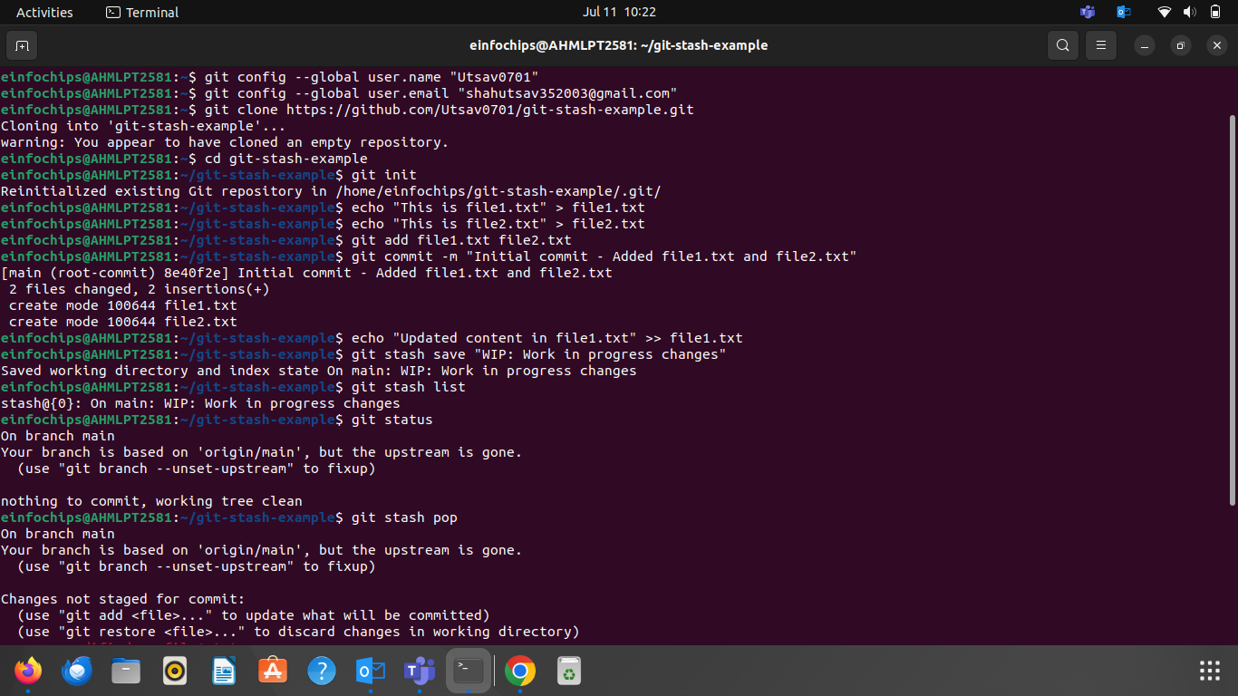

### **Docker Project 01**

### **Part 1: Creating a Container from a Pulled Image**

**Objective:** Pull the official Nginx image from Docker Hub and run it as a container.

**Steps:**

**Pull the Nginx Image:**  
docker pull nginx

**Run the Nginx Container:**  
docker run --name my-nginx -d -p 8080:80 nginx

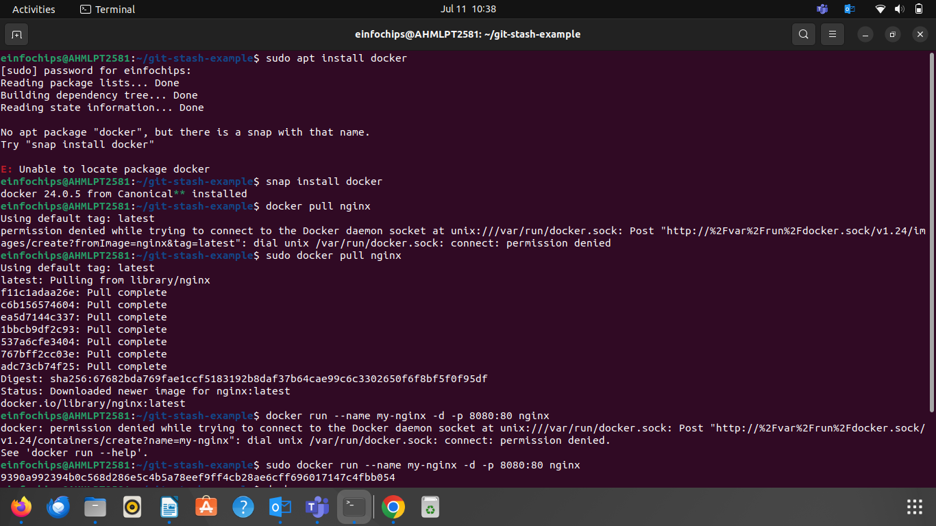

* + --name my-nginx: Assigns a name to the container.
  + -d: Runs the container in detached mode.
  + -p 8080:80: Maps port 8080 on your host to port 80 in the container.

**Verify the Container is Running:**  
docker ps

* + Visit http://localhost:8080 in your browser.

### **Part 2: Modifying the Container and Creating a New Image**

**Objective:** Modify the running Nginx container to serve a custom HTML page and create a new image from this modified container.

**Steps:**

**Access the Running Container:**  
docker exec -it my-nginx /bin/bash

**Create a Custom HTML Page:**  
echo "<html><body><h1>Hello from Docker!</h1></body></html>" > /usr/share/nginx/html/index.html

**Exit the Container:**  
exit

**Commit the Changes to Create a New Image:**  
docker commit my-nginx custom-nginx

**Run a Container from the New Image:**  
docker run --name my-custom-nginx -d -p 8081:80 custom-nginx

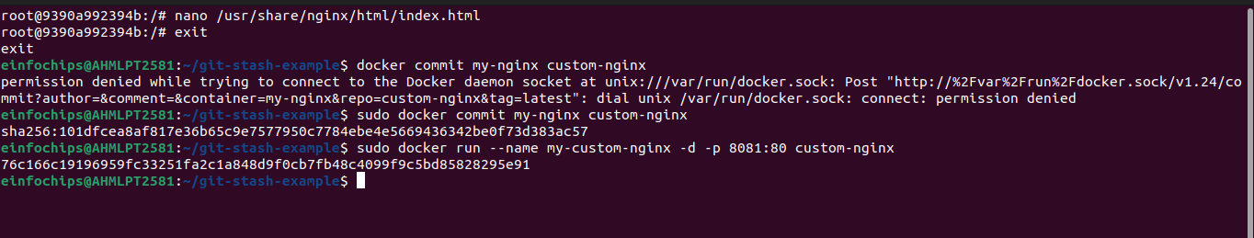

1. **Verify the New Container:**
   * Visit http://localhost:8081 in your browser. You should see your custom HTML page.

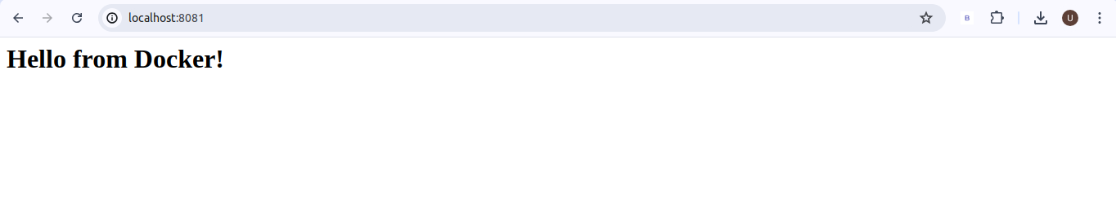

### **Part 3: Creating a Dockerfile to Build and Deploy a Web Application**

**Objective:** Write a Dockerfile to create an image for a simple web application and run it as a container.

**Steps:**

**Create a Project Directory:**  
mkdir my-webapp

cd my-webapp

**Create a Simple Web Application:**

Create an index.html file:

**Write the Dockerfile:**

Create a Dockerfile in the my-webapp directory with the following content:

**Build the Docker Ima­ge:**  
docker build -t my-webapp-image .

**Run a Container from the Built Image:**  
docker run --name my-webapp-container -d -p 8082:80 my-webapp-image

**Verify the Web Application:**

* + Visit http://localhost:8082 in your browser. You should see your custom web application.

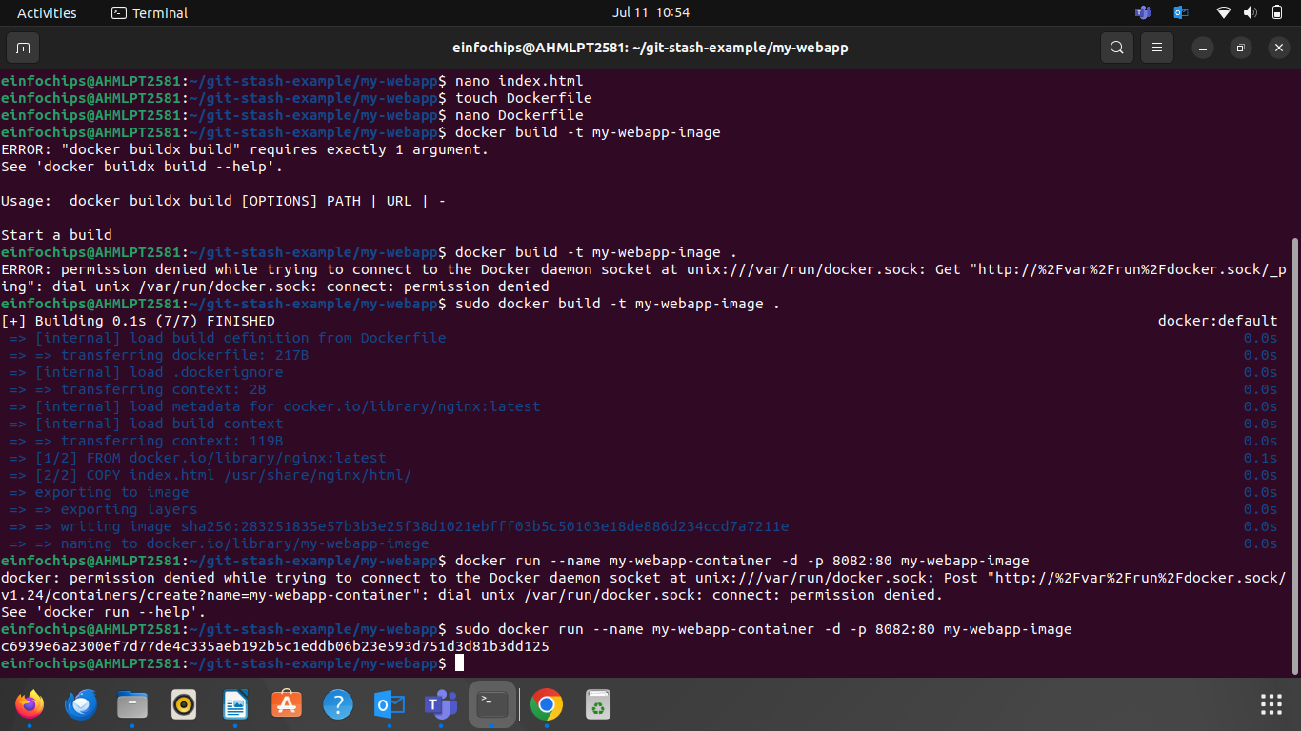

### **Part 4: Cleaning Up**

**Objective:** Remove all created containers and images to clean up your environment.

**Steps:**

**Stop and Remove the Containers:**  
docker stop my-nginx my-custom-nginx my-webapp-container

docker rm my-nginx my-custom-nginx my-webapp-container

1. **Remove the Images:**  
   docker rmi nginx custom-nginx my-webapp-image

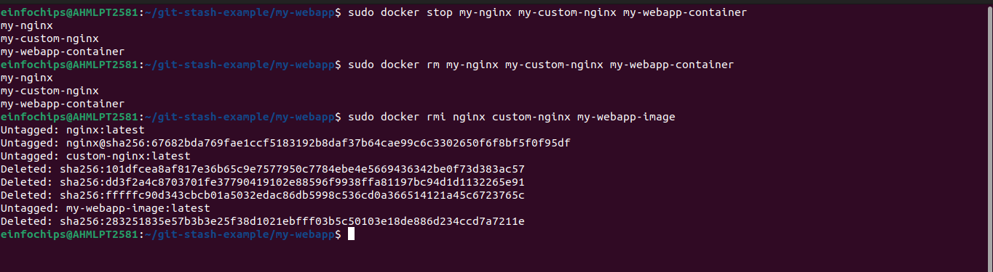

**Docker Project 02**

#### **Project Overview**

In this advanced project, you'll build a full-stack application using Docker. The application will consist of a front-end web server (Nginx), a back-end application server (Node.js with Express), and a PostgreSQL database. You will also set up a persistent volume for the database and handle inter-container communication. This project will take more time and involve more detailed steps to ensure thorough understanding.

### **Part 1: Setting Up the Project Structure**

**Objective:** Create a structured project directory with necessary configuration files.

**Steps:**

**Create the Project Directory:**  
 mkdir fullstack-docker-app

cd fullstack-docker-app

1. **Create Subdirectories for Each Service:** mkdir frontend backend database
2. **Create Shared Network and Volume:**

docker network create fullstack-network

docker volume create pgdata

### **Part 2: Setting Up the Database**

**Objective:** Set up a PostgreSQL database with Docker.

**Steps:**

1. **Create a Dockerfile for PostgreSQL:**

In the database directory, create a file named Dockerfile with the following content:

**Build the PostgreSQL Image:**  
cd database

docker build -t my-postgres-db .

cd ..

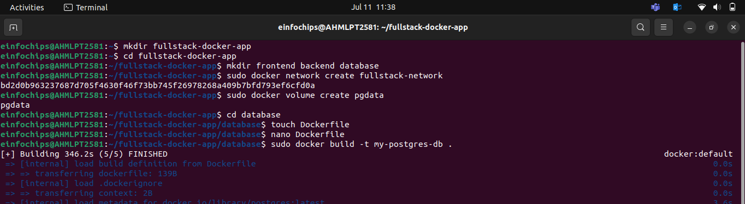

**Run the PostgreSQL Container:**  
docker run --name postgres-container --network fullstack-network -v pgdata:/var/lib/postgresql/data -d my-postgres-db

### **Part 3: Setting Up the Backend (Node.js with Express)**

**Objective:** Create a Node.js application with Express and set it up with Docker.

**Steps:**

**Initialize the Node.js Application:**  
cd backend

npm init -y

**1. Install Express and pg (PostgreSQL client for Node.js):**  
 npm install express pg

1. **Create the Application Code:**
2. **Create a Dockerfile for the Backend:**

**Build the Backend Image:**  
docker build -t my-node-app .

cd ..

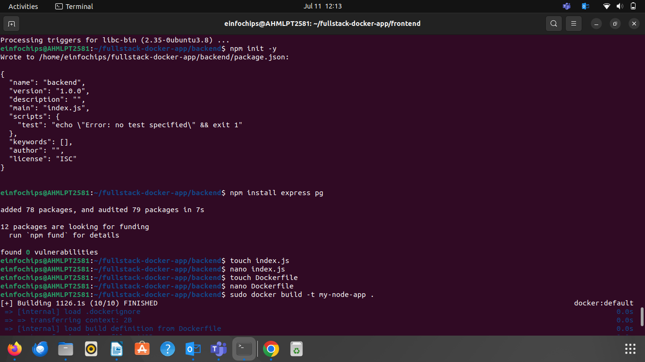

**Run the Backend Container:**  
docker run --name backend-container --network fullstack-network -d my-node-app

### **Part 4: Setting Up the Frontend (Nginx)**

**Objective:** Create a simple static front-end and set it up with Docker.

1. **Steps:**

Create a Simple HTML Page:

Create a Dockerfile for the Frontend

1. **Build the Frontend Image:**
2. **Run the Frontend Container:**  
   docker run --name frontend-container --network fullstack-network -p 8080:80 -d my-nginx-app

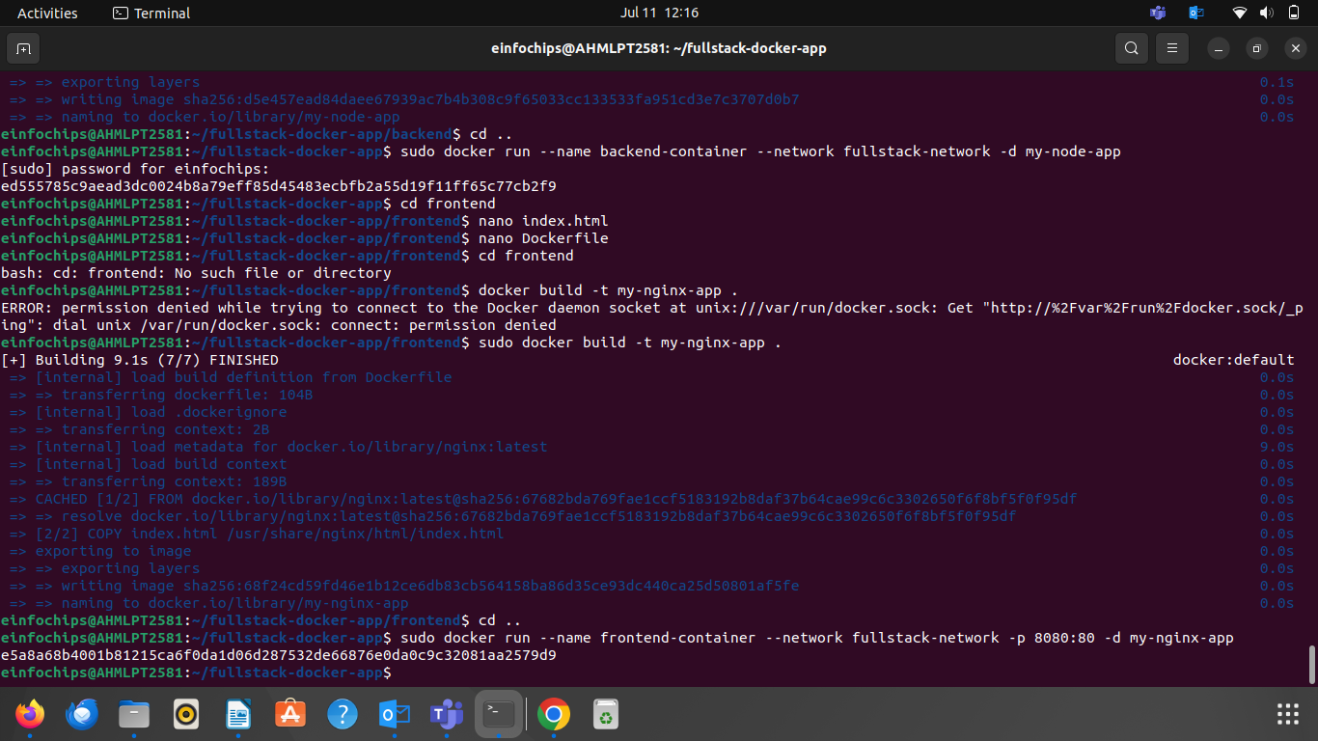

**Part 5: Connecting the Backend and Database**

**Objective:** Ensure the backend can communicate with the database and handle data requests.

**Steps:**

1. **Update Backend Code to Fetch Data from PostgreSQL:**
   * Ensure that the index.js code in the backend handles /data endpoint correctly as written above.
2. **Verify Backend Communication:**
3. Access the backend container:  
     
   docker exec -it backend-container /bin/bash
4. Test the connection to the database using psql:  
     
   apt-get update && apt-get install -y postgresql-client

psql -h postgres-container -U user -d mydatabase -c "SELECT NOW();"

1. Exit the container:  
     
   exit
2. **Test the Backend API:**
   * Visit http://localhost:3000 to see the basic message.
   * Visit http://localhost:3000/data to see the current date and time fetched from PostgreSQL.

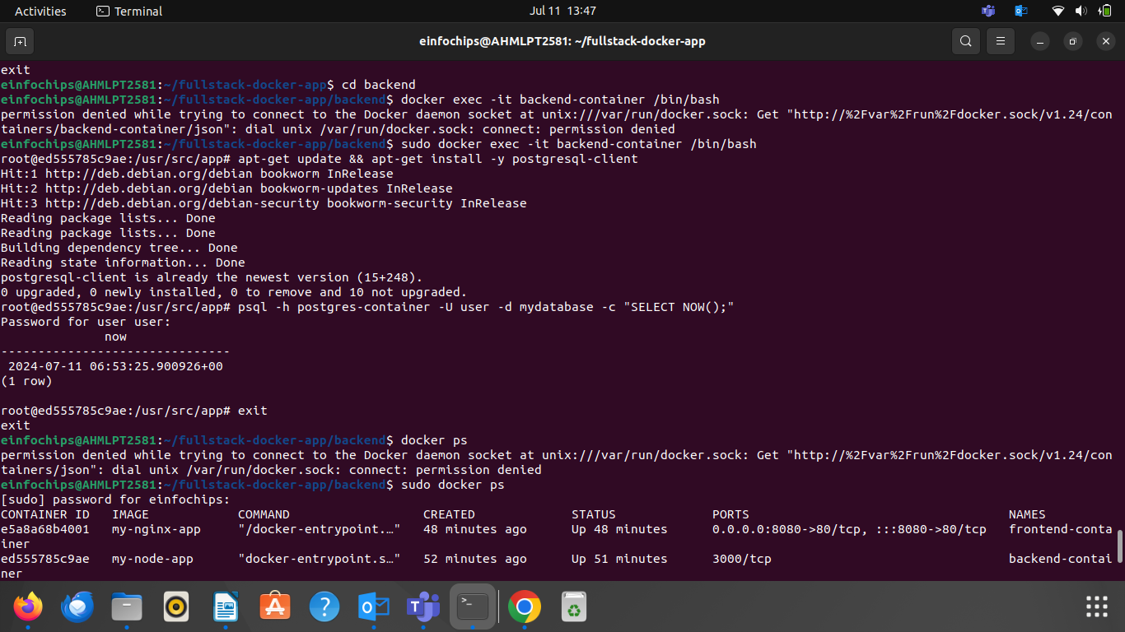

### **Part 6: Final Integration and Testing**

**Objective:** Ensure all components are working together and verify the full-stack application.

**Steps:**

1. **Access the Frontend:**
   * Visit http://localhost:8080 in your browser. You should see the Nginx welcome page with the custom HTML.
2. **Verify Full Integration:**

Update the index.html to include a link to the backend:

**Rebuild and Run the Updated Frontend Container:**  
cd frontend

docker build -t my-nginx-app .

docker stop frontend-container

docker rm frontend-container

docker run --name frontend-container --network fullstack-network -p 8080:80 -d my-nginx-app

cd ..

1. **Final Verification:**
   * Visit http://localhost:8080 and click the link to fetch data from the backend.

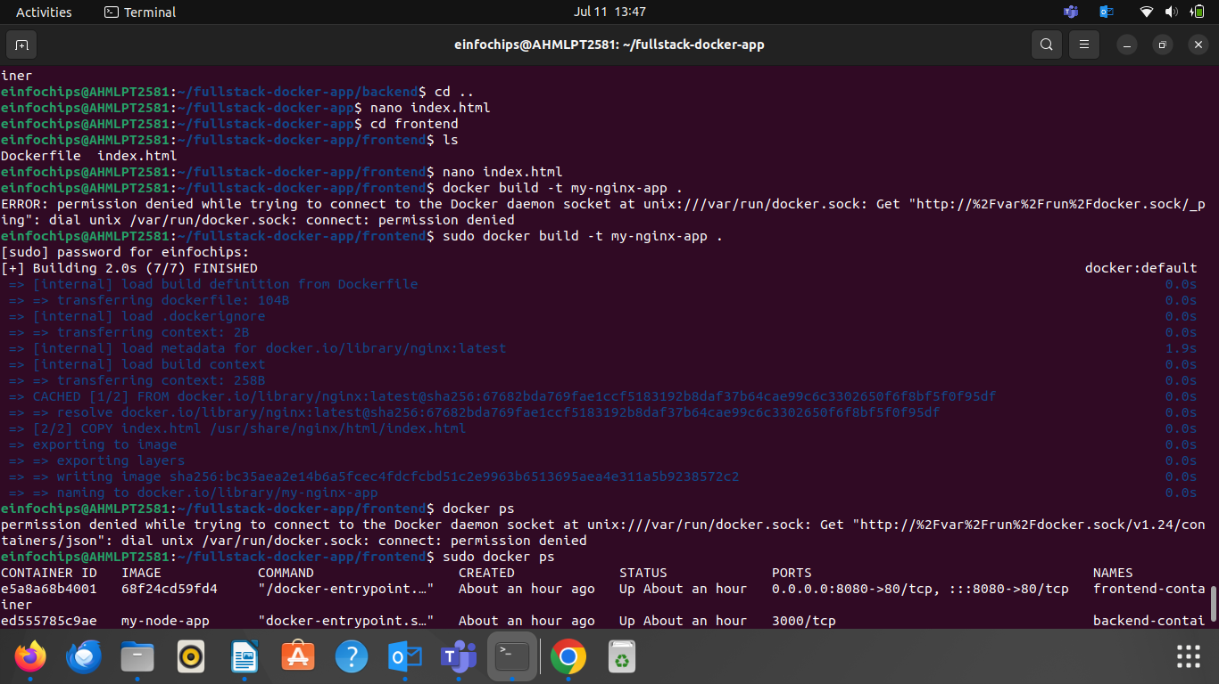

**Part 7: Cleaning Up**

**Objective:** Remove all created containers, images, networks, and volumes to clean up your environment.

**Steps:**

1. **Stop and Remove the Containers:**  
   docker stop frontend-container backend-container postgres-container

docker rm frontend-container backend-container postgres-container

1. **Remove the Images:**  
   docker rmi my-nginx-app my-node-app my-postgres-db
2. **Remove the Network and Volume:**  
   docker network rm fullstack-network

docker volume rm pgdata

